Blockchain-Based Milestone Escrow for Freelance Payments

1. Introduction
Smart contracts make payment rules public and enforceable without giving an application operator control over users' funds. In this DApp, users sign transactions with MetaMask, and an Ethereum contract applies the agreed escrow rules.
The project applies this model to freelance work. A client funds the project upfront, reviews delivery by milestone, and releases payment in stages. The scope covers custody, conditional release, disputes, refunds, and transaction history.

2. Problem Statement
Advance payment exposes a client to non-delivery; payment after completion exposes a freelancer to non-payment. A centralised escrow service reduces these risks but requires both parties to trust its custody and decisions. This project asks: How can milestone payments and disputes be handled transparently without giving one platform sole control of the funds?
The client deposits the full amount in Sepolia test ETH, and milestones settle separately. Each project has a client-appointed arbitrator. The database supports queries; the contract remains authoritative for funds and permissions.

3. Objectives
1. Hold project funds in a smart contract and settle each milestone according to approval, arbitration, or refund rules.
2. Enforce Client, Freelancer, and Arbitrator permissions and prevent duplicate payments.
3. Support creation, funding, milestone actions, disputes, and transaction queries through MetaMask.
4. Keep funds and business states on-chain while Flask and SQLite provide searchable metadata and history.
5. Make the DApp usable on desktop and in MetaMask's mobile browser with clear validation and transaction feedback.
6. Test normal and invalid workflows and assess security, usability, performance, and consistency limits.

4. System Architecture

4.1 Functional Architecture
The modules below cover the escrow lifecycle and its three participant roles.
Module | Main Functions | Roles
Wallet and Identity | Connect MetaMask; track account, network, and balance | All roles
Escrow Management | Set participants, deadline, and milestones; create and fund escrow | Client
Milestone Processing | Submit work; approve and release funds; request timeout refund | Client, Freelancer
Dispute Resolution | Raise disputes; arbitrate release or refund | Client, Freelancer, Arbitrator
Project Queries | View dashboard, escrow details, states, and available actions | All roles
Transactions and Synchronisation | Store metadata and confirmed transactions; filter history and open Etherscan | All roles, backend

Available actions depend on the wallet address, project role, and contract state. The contract performs the final permission check.

4.2 Technical Architecture
The frontend uses MetaMask and Ethers.js for signed contract calls, and Axios and REST endpoints for metadata and history.
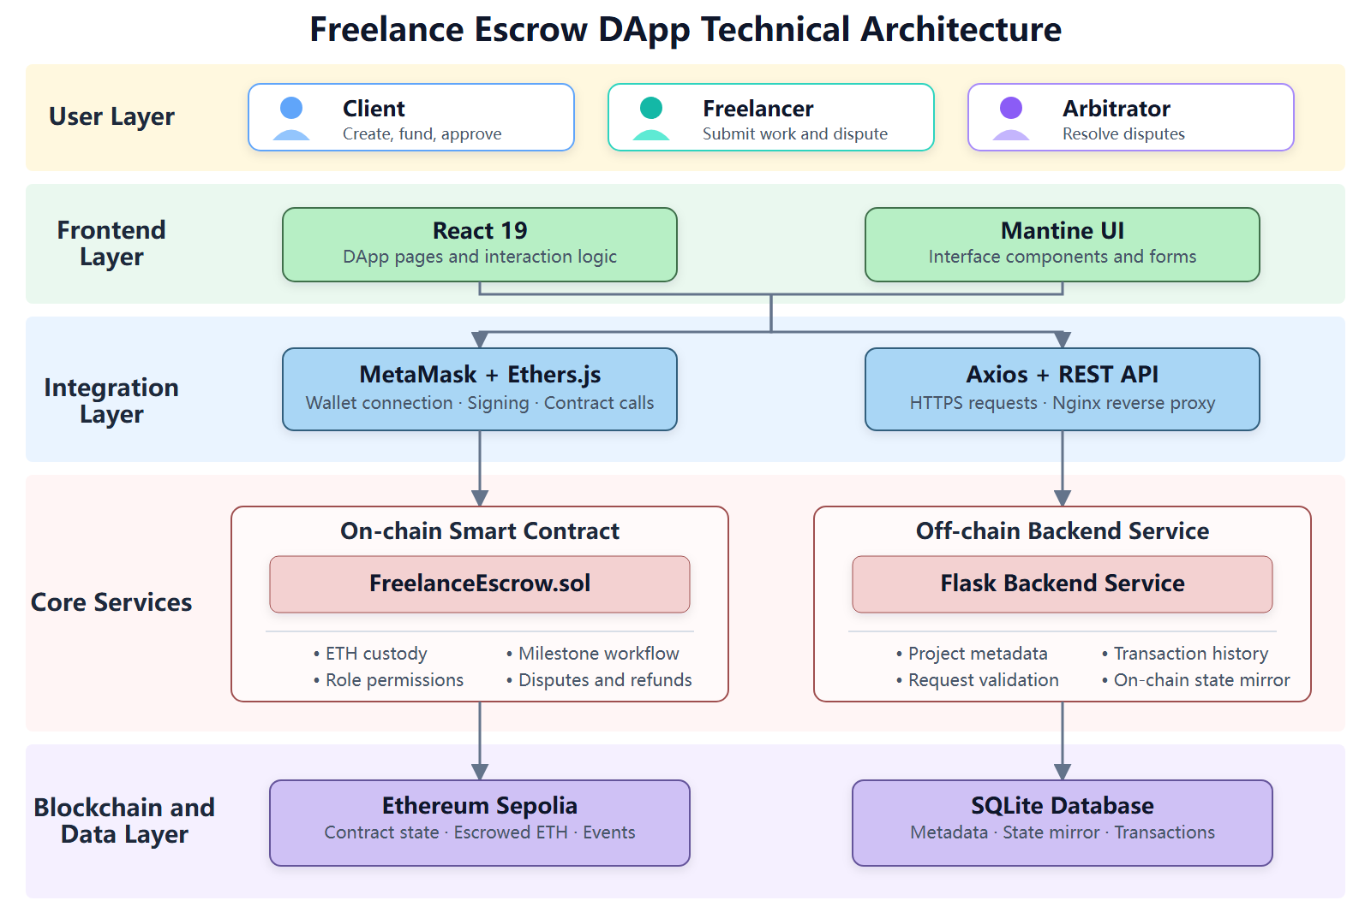
Figure 1. Freelance Escrow DApp Technical Architecture
The contract controls funds, permissions, and states. Flask stores validated application data in SQLite; it holds no private keys and does not sign transactions.

4.3 Transaction Data Flow
For milestone approval, the client confirms the action, signs approveMilestone() in MetaMask, and waits for Sepolia confirmation. The frontend then sends the transaction hash, block number, escrow ID, and action to Flask. Flask records the transaction and mirrors the RELEASED state. A database write failure triggers a warning but does not undo the on-chain transfer.

5. Technologies Used
Layer | Technology | Purpose
Blockchain | Ethereum Sepolia | Test transactions and contract events
Smart Contract | Solidity ^0.8.20 | Escrow rules, permissions, transfers, and refunds
Contract Tooling | Remix IDE | Compile, deploy, and generate ABI; build metadata records compiler 0.8.34
Wallet and Web3 | MetaMask, Ethers.js 6 | Signing, contract calls, and receipts
Frontend | React 19, Vite 8, Mantine 9 | Pages, forms, responsive UI, and notifications
Backend | Python, Flask, Flask-SQLAlchemy | REST API, validation, and persistence
Database | SQLite | Metadata, state mirror, and transaction history
Deployment | Cloud server, Nginx, Gunicorn | Serve frontend and backend separately
Version Control | Git, GitHub | Source control

6. Smart Contract Design

6.1 Data Model and State Machine
FreelanceEscrow.sol stores participant addresses, amounts, deadline, and project state in each escrow. Each milestone has a description, amount, state, and timestamps. Figure 2 shows the normal approval route, dispute branches, and the separate timeout refund path.
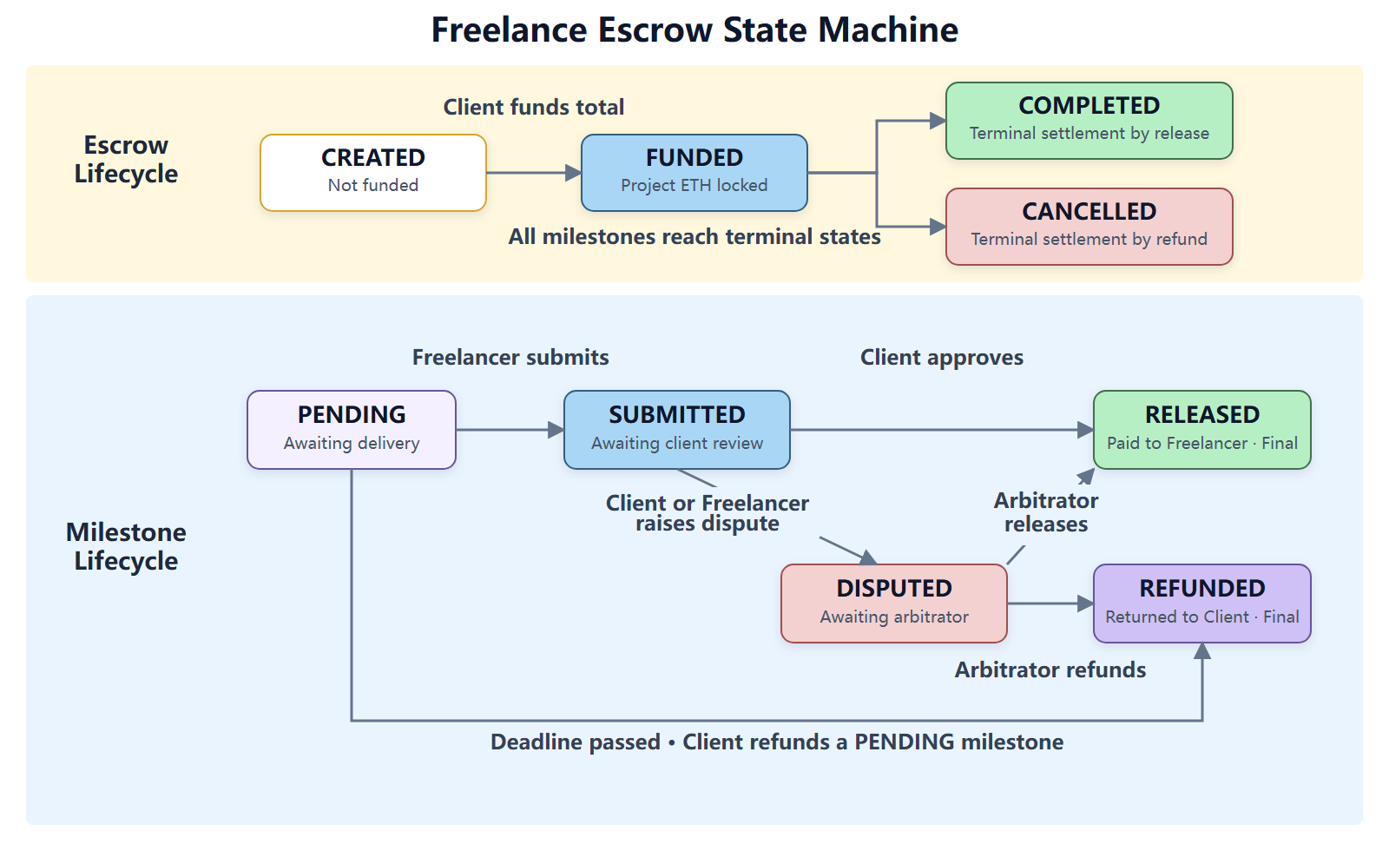
Figure 2. Escrow and Milestone State Machine
RELEASED and REFUNDED are terminal states. Once all milestones settle, the escrow becomes COMPLETED or CANCELLED.

6.2 Core Functions
Function | Caller | Main Rules and Result
createEscrow | Client | Distinct nonzero addresses, future deadline, and at least one positive-value milestone
fundEscrow | Client | CREATED escrow; deposit must equal the total
submitMilestone | Freelancer | Funded escrow; PENDING milestone
approveMilestone | Client | SUBMITTED milestone; release funds to Freelancer
raiseDispute | Client or Freelancer | Dispute a SUBMITTED milestone
resolveDispute | Appointed Arbitrator | Release to Freelancer or refund Client
refund | Client | Refund a PENDING milestone after the deadline

Each action emits an event, such as EscrowCreated, MilestoneApproved, or DisputeResolved, for blockchain auditing and future indexing.

6.3 Security Design
- Access and validation: Role checks and state guards reject unauthorised actions. Creation rejects invalid addresses, dates, empty descriptions, and zero amounts; terminal milestone states prevent repeat payments.
- Transfers: Checks-Effects-Interactions updates state before the external ETH call; a failed transfer reverts the transaction. receive() rejects direct deposits.
- Keys and amounts: MetaMask keeps signing on the user's device. Solidity 0.8 checks overflow; the application uses integer wei and numeric strings instead of floating-point amounts.
Creating an escrow stores every milestone description on-chain, so longer or more numerous milestones raise gas costs.

7. Application Design

7.1 Frontend Pages and Interaction
The frontend has four pages: Dashboard presents role-specific projects and statistics; Create Escrow collects participants, deadline, and milestones in three steps; Escrow Detail shows funding and milestone states with role-specific actions; and Transaction History filters records and links to Sepolia Etherscan. Forms validate addresses, distinct roles, future dates, descriptions, and positive ETH amounts with up to six decimal places. Irreversible actions require confirmation.
The MetaMask mobile browser is the primary interface. It uses bottom navigation, a compact header, touch targets of at least 44 px, stacked actions, and transaction cards. Desktop users see side navigation and tables. Long titles and addresses wrap or shorten, with copy and explorer links where relevant.

7.2 Backend API and Database
Flask uses an application factory and registers its blueprints under /api. The main endpoints are:
Method | Endpoint | Function
GET | /api/escrows | Query and paginate escrows by address, role, and state
GET | /api/escrows/<id> | Return one escrow and its milestones
POST | /api/escrows | Store project metadata after on-chain creation is confirmed
GET | /api/transactions | Query transaction history by escrow, address, action, and status
POST | /api/transactions | Store a confirmed transaction and update the off-chain state mirror

SQLite stores escrows, milestones, and transactions. Addresses are normalised to lowercase; amounts are stored as wei strings. Unique milestone keys and transaction hashes prevent duplicates. The API validates request fields and returns stable error codes.

8. Implementation

8.1 Wallet and Blockchain Calls
The EIP-1193 provider connects through eth_requestAccounts, restores authorisation through eth_accounts, and responds to accountsChanged and chainChanged. WalletContext shares account and network state. Write operations request a MetaMask signature, await the receipt, and show status through Mantine Notifications. After creation, the frontend reads escrowId from EscrowCreated; confirmed actions are then reported to the backend.

8.2 Data Consistency and Error Handling
The interface distinguishes blockchain confirmation from database synchronisation. If an escrow is created on-chain but saving its metadata fails, the user sees a synchronisation warning rather than a failed-transaction message. Unique transaction hashes prevent duplicate records; only CONFIRMED records update mirrored states. API errors, rejected signatures, and contract reverts produce separate feedback.

8.3 Deployment
The frontend and backend run as separate services on a self-hosted cloud server. npm ci && npm run build produces frontend static files for Nginx, which also handles SPA fallback and proxies /api to the Flask service started by Gunicorn with run:app. The browser uses one origin without connecting to the internal backend port. The frontend build receives the Sepolia contract address through an environment variable and includes the contract ABI. The primary site is https://escrow.wuziran.fun/.
The project also has a backup deployment on Render. Its frontend is available at https://freelance-escrow-front.onrender.com, and its backend is available at https://freelance-escrow-api.onrender.com. The Render backend may sleep after a period without requests. If the backup frontend cannot retrieve data on the first visit, opening https://freelance-escrow-api.onrender.com/api/escrows?page_size=1 starts the backend service; the frontend can then be refreshed. The self-hosted URL above is recommended for assessment.

9. Testing and Results

9.1 Test Environment and Functional Verification
Manual tests used separate Client, Freelancer, and Arbitrator MetaMask accounts on Sepolia. The cases cover successful flows, invalid input, and unauthorised actions.

9.2 Test Cases and Results
Module | Test Case ID | Procedure | Expected Result | Actual Result
Wallet Connection | T01 | Connect, refresh, then switch MetaMask account and network | Authorisation restores; address, balance, network, and project data update | Pass
Escrow Creation | T02 | Create with valid participants, future deadline, and milestones | Contract returns escrow ID; backend stores metadata | Pass
Escrow Creation | T03 | Submit invalid address, repeated role, past date, empty description, or zero amount | Form or contract rejects creation with an error | Pass
Escrow Funding | T04 | Fund the exact total as Client | Funds lock; state becomes FUNDED | Pass
Escrow Funding | T05 | Use wrong amount or role, or fund twice | Transaction reverts; funds and state stay unchanged | Pass
Milestone Processing | T06 | Submit as Freelancer, then approve as Client | PENDING → SUBMITTED → RELEASED; Freelancer receives milestone funds | Pass
Milestone Processing | T07 | Repeat release or use wrong role or state | Transaction reverts; no duplicate payment | Pass
Dispute Resolution | T08 | Dispute submitted work; arbitrator chooses release or refund | State becomes DISPUTED, then RELEASED or REFUNDED; correct party paid | Pass
Dispute Resolution | T09 | Resolve as an unappointed account | Transaction reverts; dispute remains unchanged | Pass
Timeout Refund | T10 | Refund before and after deadline, including non-Client account | Only Client succeeds after deadline on a PENDING milestone | Pass
Project Display | T11 | View dashboard and detail as each role | Relevant projects, statistics, states, and actions appear | Pass
Transaction History | T12 | Filter confirmed transactions | History, pagination, and Etherscan links work | Pass
User Interface | T13 | Use desktop and MetaMask mobile browsers | Layout fits; key controls remain usable | Pass
Error Handling | T14 | Reject signing or simulate API failure | Specific error and retry or cancel path appears | Pass

9.3 Mobile Test Screenshots
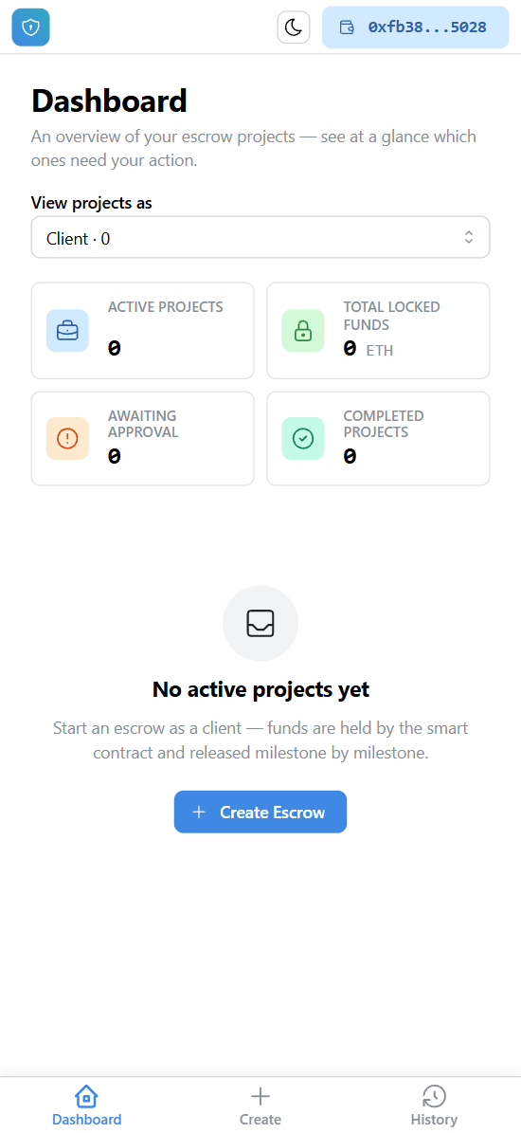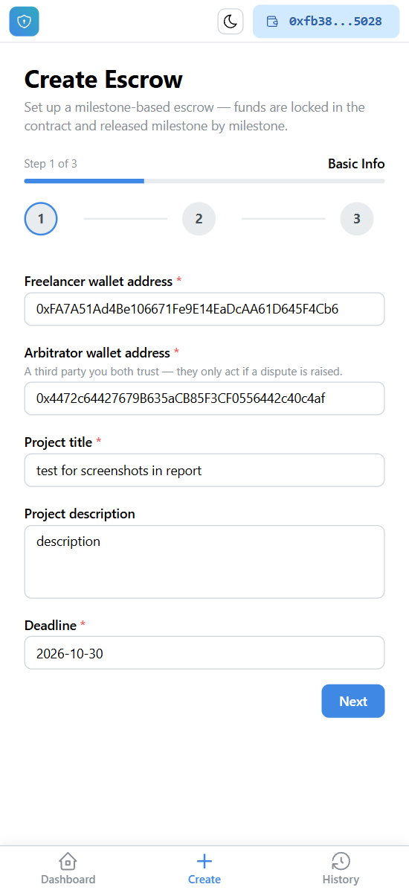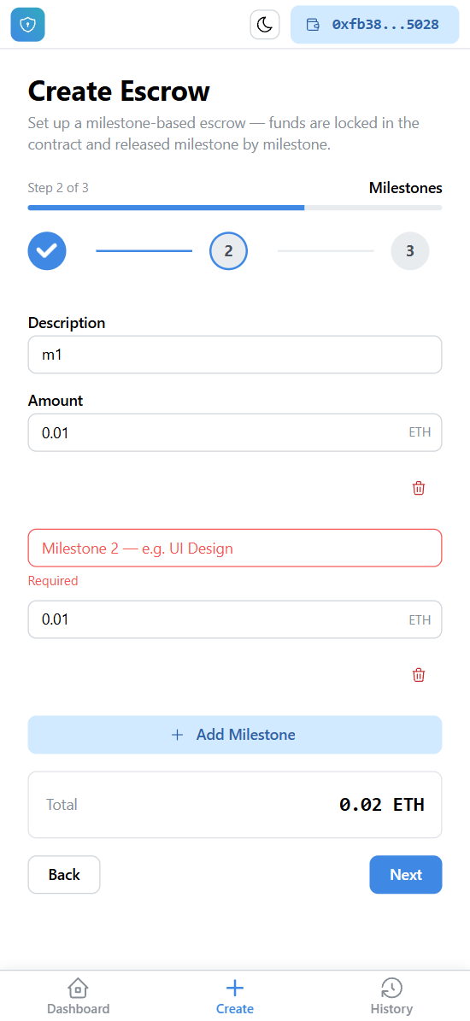
Figure 3. Client View and Escrow Creation
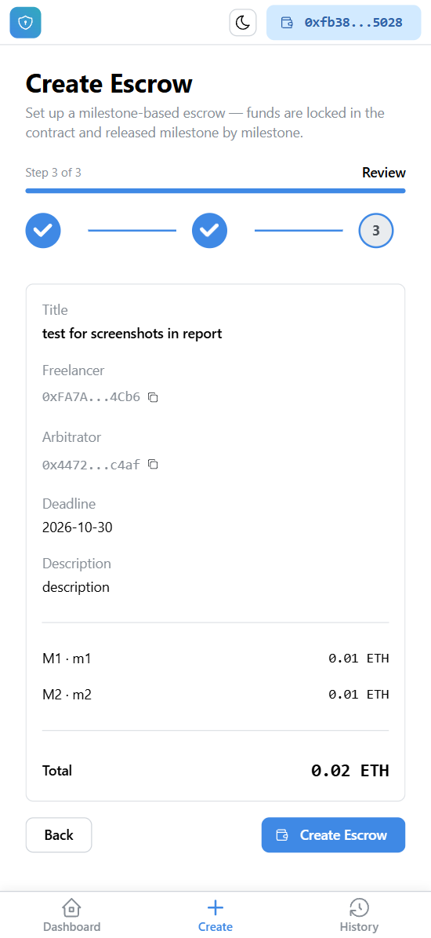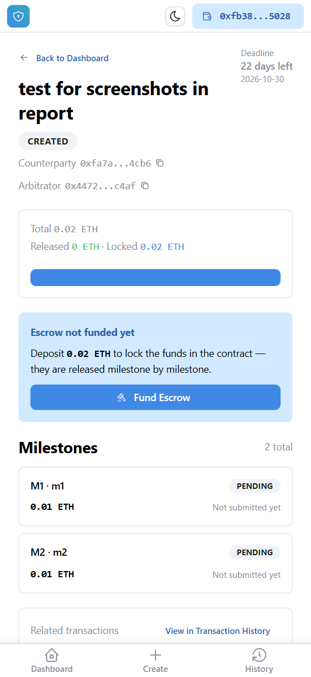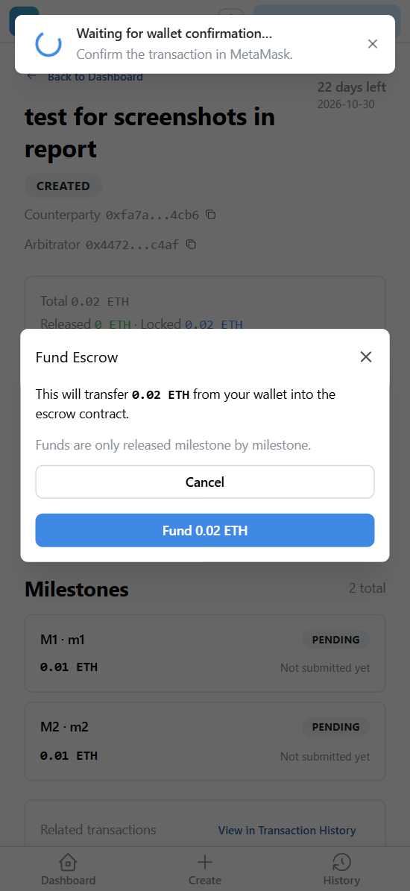
Figure 4. Escrow Funding
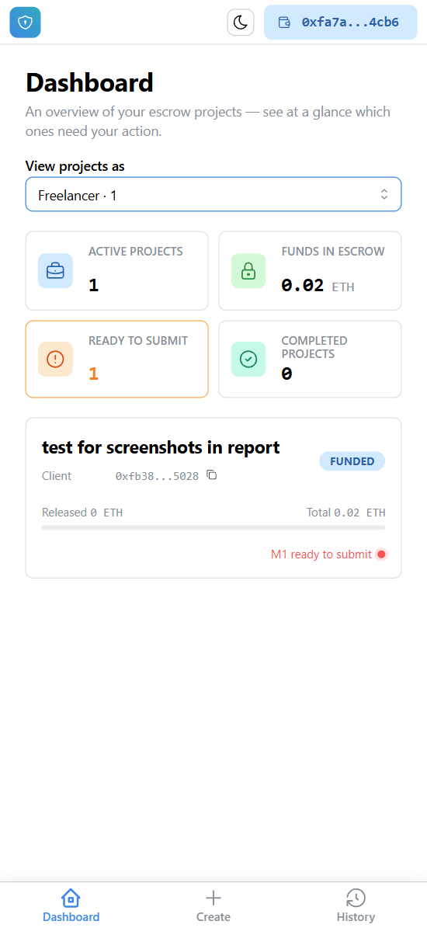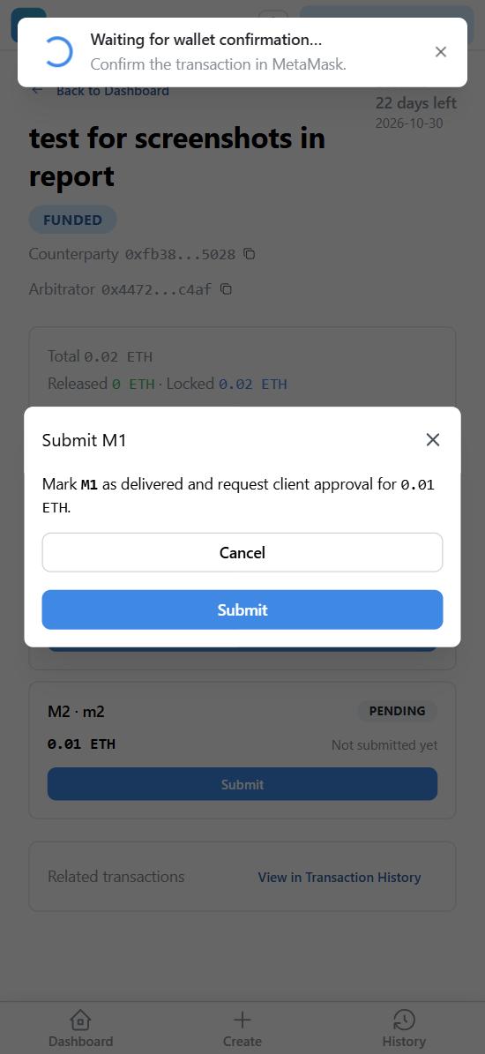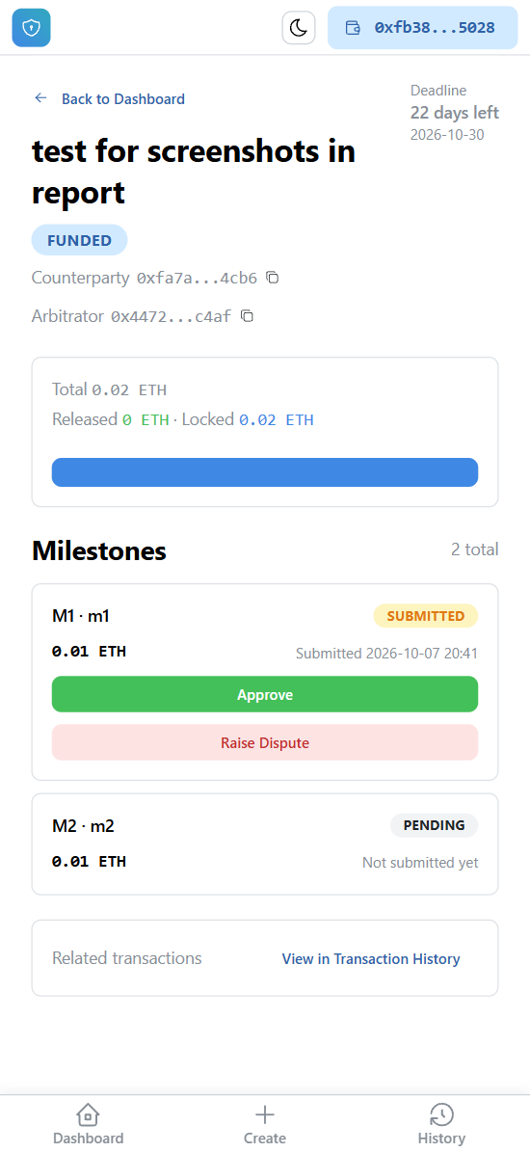
Figure 5. Freelancer Submission and Client Approval or Dispute
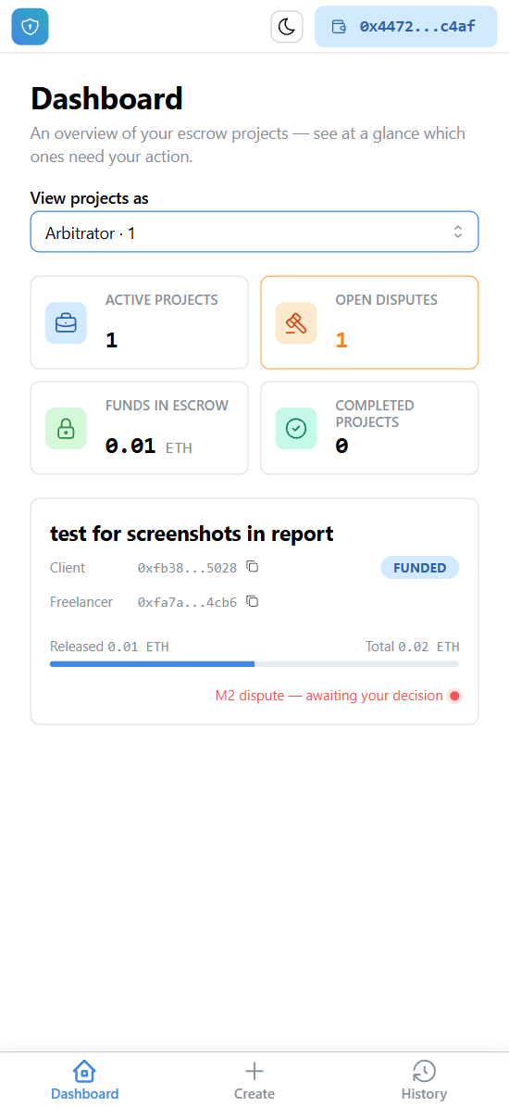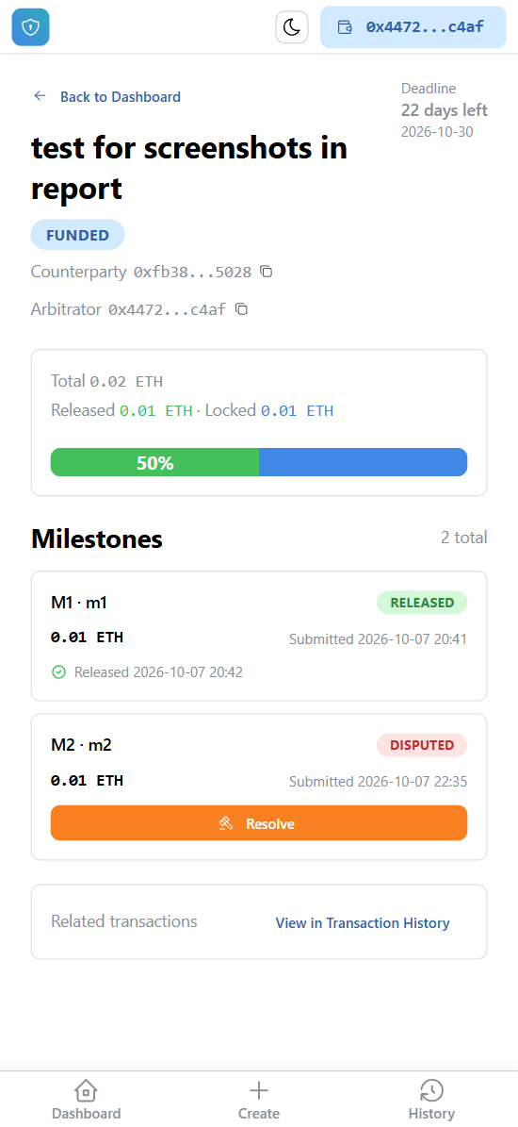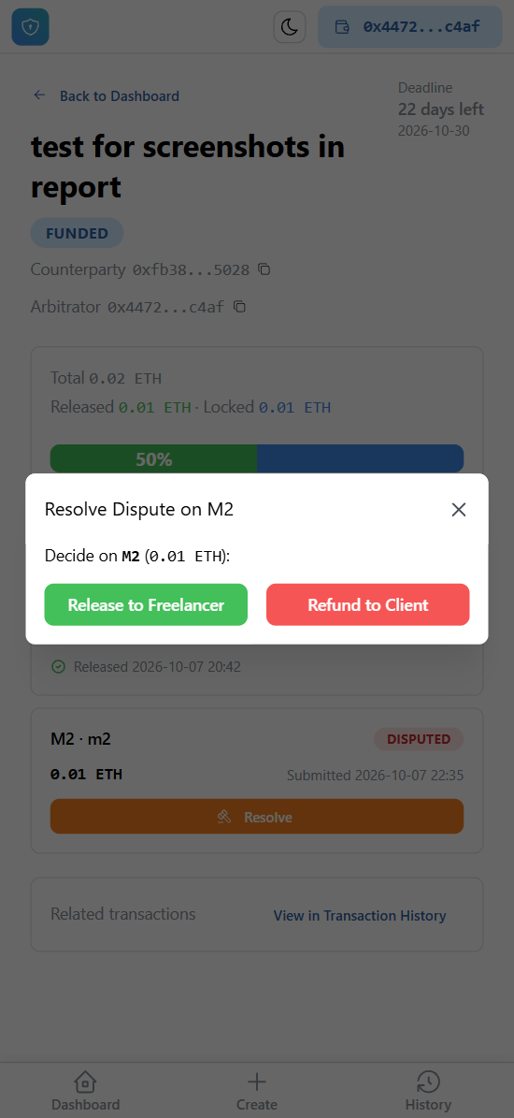
Figure 6. Client Dispute and Arbitrator Resolution

9.4 Results Evaluation
The tested workflows passed, and invalid actions were rejected. Confirmed state changes appeared in the interface and history. Tests were manual; automated contract and API tests remain outstanding.

10. Challenges Encountered
1. State synchronisation: A confirmed on-chain transaction can be followed by a failed backend write. The UI treats the chain result as authoritative and warns about the missing mirror.
2. Roles and states: A wallet may hold different roles across escrows. Detail-page checks derive available actions from both role and state.
3. ETH precision: parseEther, BigInt, and wei strings avoid JavaScript floating-point errors.
4. Mobile layout: Bottom navigation, cards, stacked buttons, and safe-area spacing support MetaMask's limited viewport.

11. Limitations
- The backend does not independently verify reported transactions through RPC or index contract events. Its mirror can be incomplete or polluted by falsified requests, though on-chain funds are unaffected.
- One appointed arbitrator can delay a dispute indefinitely by remaining inactive.
- On-chain descriptions raise gas costs and cannot be deleted.
- History is saved after confirmation; the PENDING filter has no persisted pending records.
- Public, linkable addresses provide pseudonymity, not anonymity.

12. Future Improvements
- Index contract events with saved block checkpoints and verify reported receipts through RPC.
- Assess pull payments, ReentrancyGuard, pause controls, and emergency recovery.
- Add multisignature or decentralised arbitration with timeout and replacement rules.
- Move long descriptions off-chain and retain their hashes on-chain.
- Persist pending and failed transactions and reconcile database records with chain events.

13. Conclusion
The DApp demonstrates milestone-based freelance escrow on Sepolia. Its contract enforces custody, roles, settlement, disputes, and timeout refunds, while MetaMask signs transactions and Flask provides searchable metadata and history. Manual tests covered the main and invalid workflows. Independent verification of off-chain records, automated tests, arbitration resilience, and gas efficiency remain the principal improvements.

